RFC: Unified Web Runtime
Convergence Architecture
Platform Engineering · Web Platform Team
October 2026 · DRAFT v6

Status: Draft for review · v6 adds the detailed design of each component, the developer workflow, resiliency, multi-region and security
Applies to: CBx Channel · JPMM Channel · All channel teams

Summary
Today, CBx and JPMM are served by two independent web channel stacks, and channel teams build every experience twice. This RFC proposes converging both channels onto one platform. Tenant owners configure their tenant in the DE Console, which is also the catalog where every module and version is defined. WCR (Web Composition Registry) turns each config change into one immutable manifest, stores it in S3 and releases it through dev, sit, perf, uat and prod by moving a small pointer per environment, with blue-green, canary and instant rollback. A Go Web Runtime Service serves every page from memory, and one versioned Web Runtime in the browser loads the experience frame and pages from CDAaS. OCS and Resolver stay as personalisation services, and OCS checks access with OPA. The result: one runtime, one config surface, one release path. Channel teams build once.
 | Details
Problem | Two channel stacks · channel teams build every experience twice · no shared config surface
Solution | DE Console (config + module catalog) · WCR · manifests and pointers in S3 · Web Runtime Service (Go) · one Web Runtime (CDN)
Timeline | About 32 weeks across 6 phases (indicative)
Teams affected | CBx platform, JPMM/OCS platform, all channel teams, DE Console

What changed in v6
v6 keeps the problem statement and goals of v5 and replaces the design sections with the detailed design that the proof-of-concept has validated. The main changes:
- Web Runtime Config Service is now WCR (Web Composition Registry). It builds and releases manifests but stores nothing itself: manifests, pointers and release records live in S3. There is no database and no Redis on the request path.
- The DE Console is the only authoring surface and the module catalog. Modules and their versions are defined there. The separate Registry and the automatic "auto-patch" of module versions are removed; tenant owners pick versions, and developers never edit tenant config.
- Manifests are generated, not authored. WCR builds them from the DE Console config, so they are always complete and valid.
- Five environments with gated promotion. One manifest is built once and promoted unchanged through dev → sit → perf → uat → prod, with blue-green, canary, preview and rollback inside each environment.
- OCS and Resolver are retained as personalisation services. They stop storing release config. OCS checks access with OPA; OPA is no longer embedded in the Web Runtime Service.
- The experience frame is configurable. Header, navigation and footer are versioned frame modules with per-tenant settings, released exactly like pages.
- New detail: component designs for WCR, the Web Runtime Service, the browser runtime, the DE Console, CDAaS, OCS/Resolver and the OIDC Shell; the developer workflow from laptop to production; APIs, data formats, failure modes and open questions.
- Resiliency, multi-region and security: request-path dependencies and how each degrades, an active-active multi-region design, recovery targets, and a security model with threats and controls, identities, module integrity and browser hardening.

Current State
Two separate channel stacks exist today with no shared runtime or config surface.

CBx Channel
- OIDC Shell App — handles auth flow AND serves index.html (tightly coupled; must be decoupled)
- Resolver (Java + OPA) — evaluates config and access control; integrated with Redis and Registry
- Registry — tracks module versions sourced from CDAaS; triggers auto-patch
- CBx Web Runtime — channel-specific browser bundle; to be replaced
- CDAaS — Content Delivery as a Service; already converged; retained unchanged

JPMM Channel
- OCS (Omni Channel Service) — platform-team-owned; serves index.html today
- Runtime metadata DB — JPMM-specific schema
- Profile service + Entitlements — JPMM-specific integrations
- JPMM Web Runtime — channel-specific browser bundle; to be replaced
- Console — config authoring for JPMM; integrated with OCS

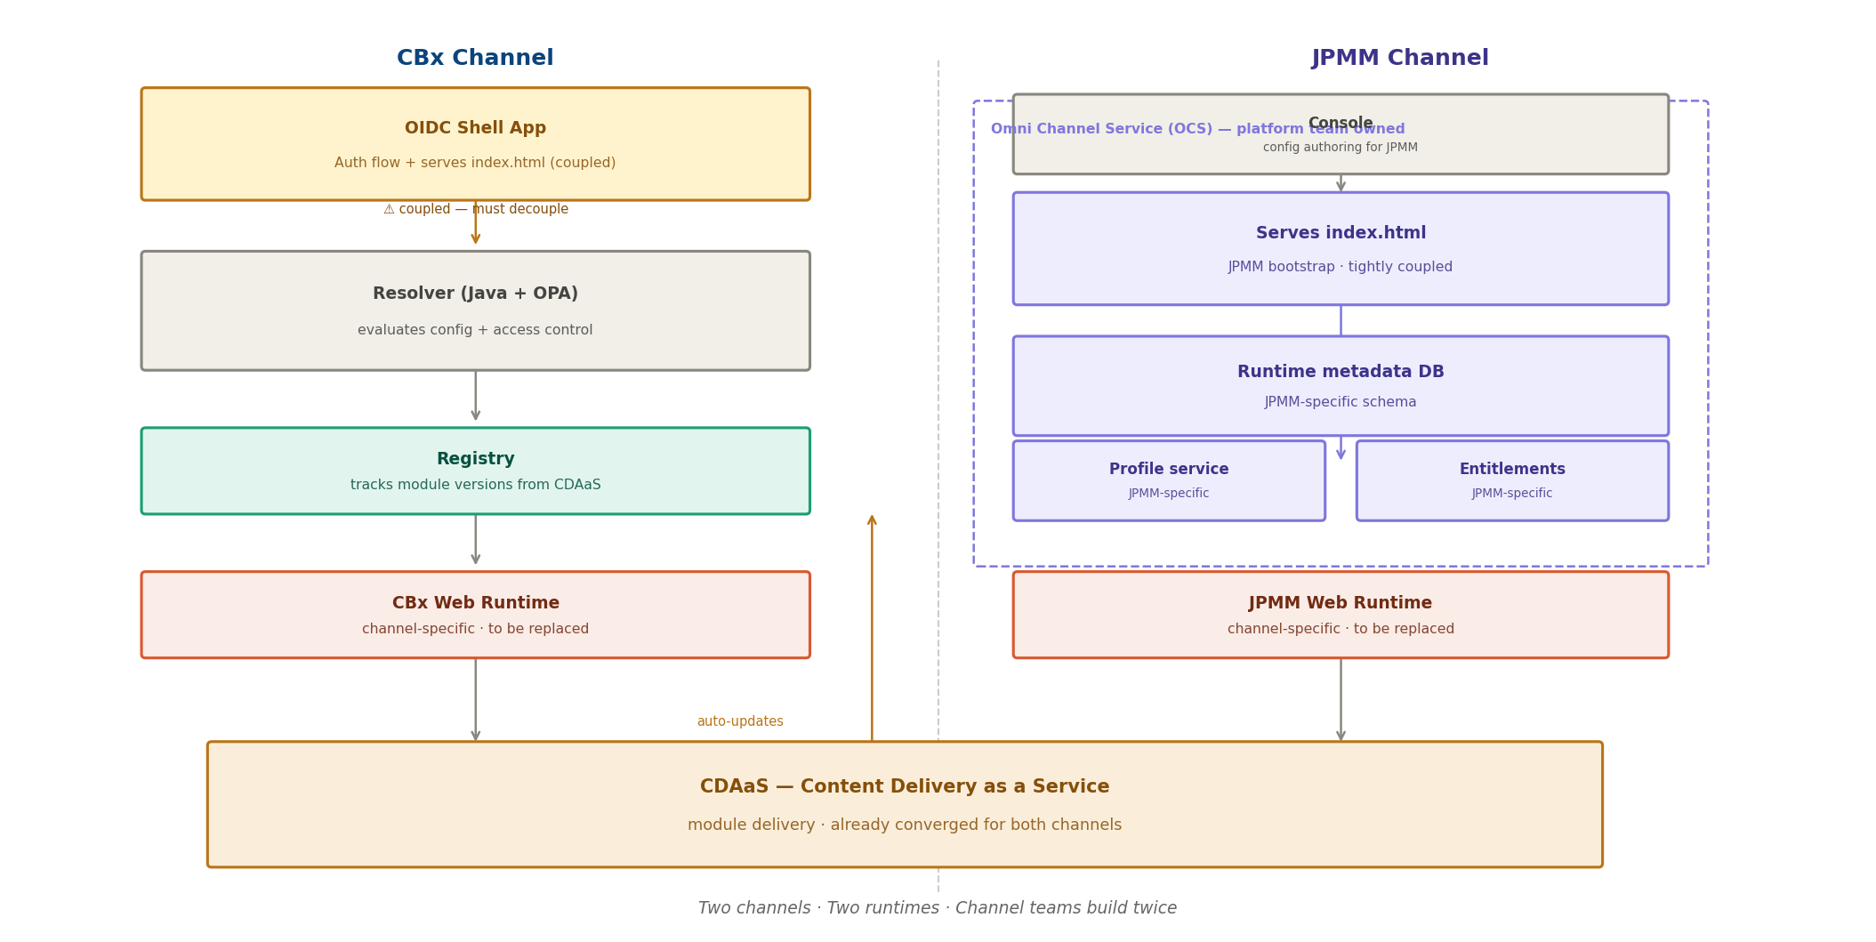
Figure 1 — Current State: two channels, two runtimes, channel teams build twice
The key friction: CDAaS is already shared and working. Everything above it is duplicated.

Why a Unified Web Runtime Platform
Two channels sharing the same mission — deliver personalised web experiences to users — today run entirely separate stacks. Every platform capability is built twice. Every incident is investigated twice. Every runtime improvement is deployed twice.
A unified web runtime platform changes this. It is one versioned runtime, one config surface and one release path. Channel teams build experiences once. Platform improvements benefit both channels immediately. The platform team owns one surface, not two.
The platform must be designed for both channels from the start. Channel-specific integrations (auth, profile, entitlements, personalisation) stay behind clear contracts, and OCS and Resolver keep their personalisation role. OCS team alignment on the personalisation contract is required before Phase 3; this RFC is a proposal to the OCS team, not a mandate.

Why the Target State
Converging the two runtimes is not enough on its own. The way config is released today is also the source of most of the friction, and a single runtime on top of today's release model would keep it. The target state fixes how a change travels from authoring to users, not only where it is served from.

What Hurts Today
Friction today | Effect | Target state answer
Every experience and platform capability is built for CBx and again for JPMM | Double cost, double incidents, features drift apart | One runtime, one module contract, one release path for both channels
JPMM config is copied into OCS separately in each environment | What runs in prod cannot be proven to be what was tested in uat | One immutable manifest, built once and promoted unchanged; same bytes in every environment
Rollback means promoting older config into each environment again | Slow, manual and error-prone during an incident | Rollback is pointing stable at an earlier version: seconds, nothing rebuilt
CBx resolves config on every request through the Resolver and OPA | Latency on every page; config service outage is a user outage | Config resolved once at build time; pages served from memory; control plane off the request path
The Registry auto-patches module versions on deploy | A module change can reach users without passing any environment gate | Every change is a new manifest version that goes through the gates; owners adopt versions
No per-tenant canary or preview of the next release | Every release is all-or-nothing | Preview, sticky canary and blue-green per tenant per environment
Header, navigation and footer are fixed in each runtime | Brand or layout changes need a runtime release | Experience frame as versioned modules with per-tenant settings
Module versions, config and release state live in different places per channel | Hard to answer "what is live, where, and why" | DE Console for config and catalog; WCR release records for where each version is live

Why Not Improve the Current Stacks Instead
- Extending OCS to serve CBx keeps per-environment config copies and environment-by-environment re-promotion, and is effectively a rewrite inside a live production system.
- Extending the Resolver to JPMM keeps per-request config resolution on the hot path for both channels.
- Keeping both stacks and sharing libraries reduces some duplicate code but keeps two release models, two runtimes and two sets of incidents.
Each option fixes one symptom and keeps the release model that causes the rest. The target state changes the release model once, for both channels, and reuses what already works: the DE Console, CDAaS, OCS and Resolver for personalisation, and OPA.

What the Target State Delivers
- Safety: every change is versioned, validated, tested in each environment and reversible in seconds.
- Speed: a config change is live in dev within seconds; promotion and rollback are pointer moves.
- Resilience: users are served from memory; authoring and release systems can fail without user impact.
- Cost: one platform to build, run and improve; channel teams build once.
- Clarity: one answer to "what is live for this tenant in this environment, and since when".

Platform Capabilities
The unified platform delivers the following capabilities across both channels.
# | Capability | How the platform delivers it
1 | Multi-tenant config | One config per tenant in the DE Console; every save creates a new config revision
2 | Immutable manifests | Each config revision becomes one manifest version v{n} in S3; never overwritten; full history kept
3 | Build once, promote unchanged | Manifests hold module paths, not hosts, so the same file runs in every environment
4 | Five environments with gates | dev → sit → perf → uat → prod; only to the next environment, only if stable in the previous one
5 | Blue-green per environment | Stable and candidate pointers per tenant per environment; promote is a pointer change
6 | Canary | Sticky per-user bucket; 10 / 25 / 50 % or any percentage; raising it only adds users
7 | Preview | Testers view the candidate with a preview flag before it takes traffic
8 | Instant rollback | Point stable at any earlier version in seconds; nothing is rebuilt; other environments untouched
9 | Validation before release | Schema, catalog, module kind and slot, settings types, URL and colour safety checked before dev
10 | Module catalog | The DE Console lists every module and version; tenants reference exact versions
11 | Configurable experience frame | Header, navigation and footer are versioned modules with per-tenant settings and theme
12 | Fast propagation | A pointer change reaches every serving pod in about a second; a 5 s poll is the safety net
13 | Static stability | If S3, WCR or the DE Console is down, pages keep being served from memory
14 | Audit and diff | A release record per version shows where and when it was stable; WCR diffs any two versions

Architecture Goals
Derived from first principles — each goal answers a question that any web platform must answer:
- G1 — Build once, deploy everywhere: channel teams write one experience; it runs on all channels and tenants.
- G2 — Fast first paint: the server renders index.html with the frame, navigation and first data already inside; no extra round trips before render.
- G3 — Config is versioned and immutable: every manifest version is stored, diffable and rollback-capable; the file promoted to prod is byte-for-byte the one tested in uat.
- G4 — Auth is separate from delivery: the OIDC Shell signs users in; it does not serve index.html.
- G5 — Runtime is independently versioned: the browser bundle is CDN-delivered and versioned per tenant through the manifest.
- G6 — Module delivery is already solved: CDAaS continues unchanged; manifests only reference module versions.
- G7 — The control plane is off the request path (changed in v6): the DE Console and WCR can be down without affecting users; only releases pause.
- G8 — One authoring surface (new in v6): config and the module catalog live in the DE Console; nothing downstream is edited by hand.
v5 had "G7 — Access control is embedded, not networked". v6 keeps access decisions with OCS, which calls OPA, because OCS already knows the user's entitlements. If latency measurements require it, OPA can be embedded later without changing the manifest or the release path (see Open Questions).

Target Architecture
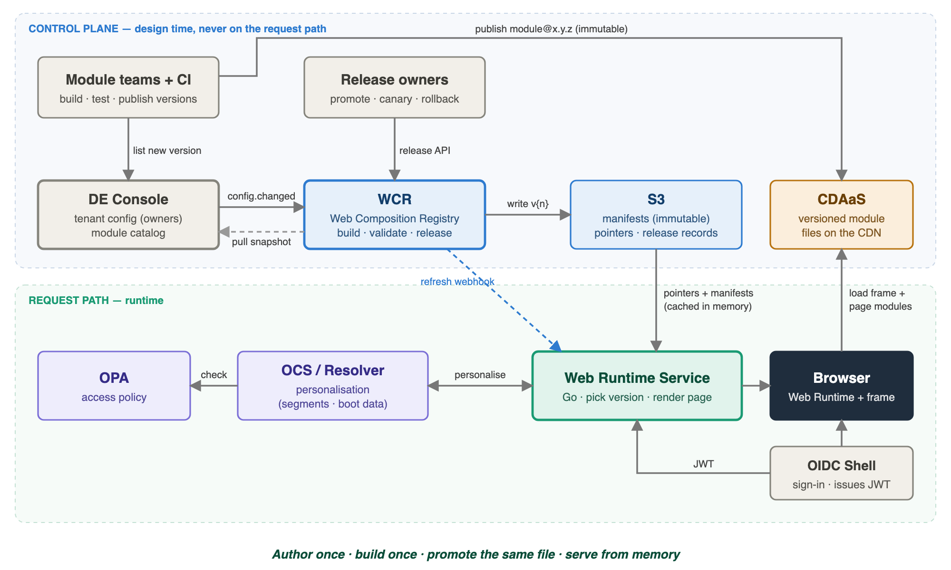
Figure 2 — Target architecture: control plane (DE Console, WCR, S3) and request path (Web Runtime Service, OCS/Resolver, OPA, browser, CDAaS)
The architecture splits into a control plane, which turns config into released manifests, and a request path, which serves pages. They meet only in S3: WCR writes manifests and pointers, and the Web Runtime Service reads them into memory.

How the pieces fit together
1. Module teams' CI publishes a new module version to CDAaS, and the version is listed in the DE Console catalog.
2. A tenant owner changes config in the DE Console (for example picks home@1.1.0) and clicks Save and publish. The DE Console stores a new config revision and sends config.changed to WCR.
3. WCR pulls that revision together with the catalog entries it uses, builds one manifest, validates it and writes it to S3 as v{n}. It points dev at it and tells the Web Runtime Service.
4. Release owners promote the version through sit, perf, uat and prod using the WCR release API (from the DE Console UI). Each step only moves a pointer.
5. On every page request the Web Runtime Service picks a version for the user from the pointer it holds in memory, asks OCS or Resolver to personalise (OCS checks access with OPA) and returns index.html with everything needed for first paint.
6. The browser's Web Runtime loads the frame and page modules from CDAaS.

Key Components
Component | What it does | Status
DE Console | Tenant config authoring and the module catalog. Stores config revisions in its own database; emits config.changed; hosts the release UI. | Retained, extended (catalog, frame, releases)
WCR (Web Composition Registry) | Builds and validates one manifest per config revision; stores manifests in S3; owns per-environment pointers, promotion gates, canary and rollback. | New (replaces v5 "Web Runtime Config Service")
S3 | Immutable manifests, pointer per tenant per environment, release records. | New
Web Runtime Service (Go) | Verifies the token, picks the version per user, calls OCS/Resolver, renders index.html with __PLATFORM_STATE__. Holds pointers and manifests in memory. | New (takes over serving from OCS and Resolver)
Web Runtime (browser) | Versioned browser orchestrator: frame host, client router, platform bus, module loader. CDN-delivered. | New (replaces CBx and JPMM runtimes)
Experience frame modules | Header, navigation and footer as versioned modules with settings. | New
OIDC Shell | Sign-in only; issues the token. Does not serve index.html. | Retained (decoupled)
CDAaS | Module delivery from versioned, immutable paths on the CDN. | Retained unchanged
OCS (Omni Channel Service) | Personalisation for JPMM: segments, visible pages and variants, boot data. Checks access with OPA. | Retained (stops storing release config)
Resolver | Personalisation for CBx behind the same contract. | Retained (stops resolving config)
OPA | Access policy: which users and channels may see which tenants and pages. Called by OCS. | Retained
CBx Registry | Module versions are defined in the DE Console catalog instead. | Retired
JPMM runtime metadata DB | Release config moves to manifests in S3. | Retired after migration

Core Concepts
Concept | Meaning
Tenant | One business app, such as a bank's portal: its pages, roles and frame. Released separately in each environment.
Experience module | The code for one page, such as Home. Published to CDAaS as an immutable version (home@1.1.0).
Frame module | A header, navigation or footer module. Versioned like pages, with a settings schema.
Module catalog | Every module and all its versions, defined in the DE Console. Modules belong to no tenant; tenants reference them.
Config revision | A saved snapshot of a tenant's config in the DE Console. Revisions only increase.
Manifest v{n} | The complete, validated description of a tenant built by WCR from config revision n. Immutable.
Pointer | A small file per tenant per environment saying which manifest version is stable, which is the candidate, and the canary share.
Release record | Per manifest version: the environments where it has been stable and its history.
Environment binding | Per environment: the CDAaS host and data hosts the runtime adds to manifest paths.
Stable / candidate / canary / preview | Stable serves everyone; candidate is the next version; canary sends a share of users to it; preview lets testers open the candidate.

What Is Configured Where
Every kind of setting has exactly one home and one owner. The manifest is an output, not an input: nobody edits it, and nobody edits a pointer file by hand.
What | Where | Who | How it changes
Pages, routes, roles per page, page → module@version | DE Console (tenant config) | Tenant owner | Save and publish → new manifest in dev → promoted
Experience frame: header, nav, footer modules, settings, theme | DE Console (tenant config) | Tenant owner | Same as pages
Modules: name, versions, CDAaS path, kind, slot, settings schema | DE Console (module catalog) | Module team, via CI | Each publish lists a new version
Module code and assets | CDAaS | Module team, via CI | A new immutable version; never overwritten
Manifest | S3, generated by WCR | Nobody edits it | Rebuilt for every config revision
Which version is live per environment; canary share | S3 pointers, changed only through WCR | Gate owners and release manager | Promote, canary, rollback
Environment hosts (CDAaS, data APIs) | Web Runtime Service deployment config | Platform team | Infrastructure change, not per tenant
Who can see what | OPA policy, used by OCS | Platform / security | Policy release
Personalisation per user: segments, variants, boot data | OCS / Resolver | Business / personalisation team | Rules change, limited to what the manifest allows

The Manifest

What It Is
A manifest is the complete description of one tenant that the runtime needs to serve it: navigation and routes, which module and version renders each page, the experience frame and theme, access requirements and the runtime version. WCR generates it from one DE Console config revision. Unlike v5, teams do not author manifest.json; they change config in the DE Console and the manifest is built for them.

Rules
- Immutable. manifests/{tenant}/v{n}.json is written once and never changed. A fix is a new version.
- Paths, not hosts. Module references are paths such as /home/1.1.0/App.js. Each environment's Web Runtime Service adds its own CDAaS host, so the same file is valid in dev and prod.
- Exact versions. Every page and frame slot pins an exact module version; there are no ranges or "latest" inside a manifest.
- Traceable. source records the config revision and event that produced it.
- Deterministic. The same config revision and catalog entries always produce the same bytes.
- Verified. Every module reference carries an integrity hash (SRI) of the file in CDAaS, and the browser refuses a file that does not match.
- Schema evolution. Manifest changes are additive within a major schema version. Each runtime version supports schema N and N-1, and WCR validates against the schema the target runtime supports.

Example (abbreviated, from the proof-of-concept)
{
"version": "1.0",
"tenantId": "startup-banking",
"runtime": { "version": "1.7.0" },
"shell": {
"auth": { "required": true, "roles": ["finance-user"] },
"frame": {
"theme": { "primary": "#d0bce1", "headerBg": "#9421ca" },
"header": { "module": "frame-header", "moduleVersion": "1.0.0",
"path": "/frame/header/1.0.0/App.js", "scope": "frame-header",
"settings": { "title": "Startup Banking", "logoUrl": "", "showUser": true } },
"nav": { "module": "frame-nav", "moduleVersion": "1.0.0",
"path": "/frame/nav/1.0.0/App.js",
"settings": { "position": "left", "showIcons": true } },
"footer": { "module": "frame-footer", "moduleVersion": "1.0.0",
"path": "/frame/footer/1.0.0/App.js",
"settings": { "text": "© 2026 Startup Banking",
"links": [{ "label": "Privacy", "url": "https://example.com/privacy" }] } }
},
"nav": [{
"id": "home", "label": "Home", "icon": "home", "path": "/home",
"default": true, "permission": null,
"experience": { "type": "module-federation", "scope": "home", "module": "./App",
"path": "/home/1.1.0/App.js", "moduleVersion": "1.1.0",
"dataPath": "/home/data.json" }
}]
},
"source": { "controlPlaneRevision": 9, "eventId": "d1f68d5d2ffca20e",
"generatedAt": "2026-10-19T00:50:30Z" }
}

Field Reference
Field | Meaning
tenantId | The tenant this manifest belongs to.
runtime.version | Browser Web Runtime version to load.
shell.auth | Whether sign-in is required and the roles allowed to open the tenant.
shell.frame.theme | Colours (#rrggbb) applied as CSS variables on the server.
shell.frame.{header|nav|footer} | Frame module, exact version, CDAaS path and validated settings. footer may be absent.
shell.nav[] | One entry per page: id, label, icon, route path, default page, permission key, and the experience module that renders it.
experience.path / moduleVersion | CDAaS path and exact version of the page module.
experience.integrity | SRI hash of the module file; the browser refuses a file that does not match.
experience.dataPath | Optional path the server fetches for first-render data.
source | Config revision, event id and build time, for audit.

WCR — Web Composition Registry
WCR is the composition and release service. It is a control-plane service: users never call it, so an outage only pauses releases. It has four parts: an event listener, a generator, checks, and a release API.

Why a Web Composition Registry
Something has to turn a tenant's config into a release artefact and own where that artefact is live. That job does not belong to the authoring tool or to the page server, so the target state gives it to a dedicated control-plane service.
Need | Why WCR
Compose config, exact module versions and frame into one complete document | Composition happens once, at build time. Without it the page server would compose on every request, which is today's Resolver model with its latency and runtime dependency.
Build once, promote unchanged | Build-once needs an immutable artefact produced outside any environment. WCR builds it once and every environment points at the same file.
A gate before anything reaches users | WCR validates every manifest (schema, catalog, slots, settings, URL safety) and refuses to release an invalid one.
An owner for release state | Pointers, promotion gates, canary, rollback and release records need one owner and one writer. WCR is that single writer, which makes releases consistent and auditable.
Keep production writes narrow | Only WCR's role can write manifests and pointers. The DE Console stays an authoring tool and never needs write access to production release state.
Keep the request path simple | The page server only reads files and picks a version. All composition and release logic stays in the control plane, so it can fail without affecting users.
One path for both channels | CBx and JPMM config go through the same builder and the same gates, which is what makes convergence real rather than cosmetic.

Alternatives Considered
Alternative | Why not
The Web Runtime Service composes at request time | Per-request composition (today's Resolver): latency, a config dependency on every page, and what users get can change without a release.
The DE Console builds and releases manifests itself | Possible, but couples the authoring UI with production-critical writes, gives the DE Console write access to release state, and ties release availability to the authoring tool. WCR can still start as a separately deployed module of the DE Console codebase if that is quicker, as long as it keeps its own identity, permissions and deployment.
OCS keeps storing and promoting config | Keeps per-environment copies and re-promotion, which is the main friction today.
A shared database instead of S3 | Adds a database to run and replicate; immutable files in S3 are simpler, cheaper and fit build-once.

The name reflects what it holds: the registry of composed manifest versions and of where each one is released.

Responsibilities
WCR does | WCR does not
Build one manifest per config revision | Store tenant config (the DE Console does)
Validate manifests before anything is released | Store module versions (the DE Console catalog does)
Write manifests, pointers and release records to S3 | Serve pages or sit on the request path
Enforce promotion gates between environments | Decide access per user (OCS with OPA does)
Canary, promote and rollback inside an environment | Hold a database; S3 is its only state
Notify the Web Runtime Service when a pointer moves | Deliver module code (CDAaS does)

Inputs and Outputs
Direction | Item | Detail
In | config.changed event | {id, type, tenantId, revision, occurredAt} from the DE Console outbox
In | Config snapshot | GET /api/configs/{tenant}/revisions/{n}: the config plus the catalog entries for every module@version it uses
In | Release commands | Promote, canary, rollback from the DE Console release UI or automation
Out | manifests/{tenant}/v{n}.json | Immutable manifest
Out | pointers/{tenant}/{env}.json | Stable, candidate and canary for one environment
Out | releases/{tenant}/v{n}.json | Where the version has been stable, plus history
Out | Refresh notification | Webhook (POC) or pub/sub message (production) to the Web Runtime Service

Build Pipeline
1. Receive. POST /events with config.changed returns 202 immediately. The build runs asynchronously. Events are idempotent: a (tenant, revision) that has already been built is ignored, so redelivery is safe.
2. Pull. WCR fetches the revision snapshot from the DE Console. It never reads "latest", so a newer save cannot leak into an older build.
3. Resolve. For every page and frame slot, WCR takes the exact module@version from the snapshot's catalog entries and copies its path, scope and settings schema, plus the file's integrity hash.
4. Generate. It produces the manifest with sorted keys, so identical inputs give identical bytes, and stamps source.
5. Validate. Schema; every module exists in the catalog at that version; pages use experience modules and slots use frame modules of the matching slot; settings match their types; URLs are http(s) only; colours are #rrggbb; exactly one default page; routes unique. Target state adds module-to-runtime compatibility from catalog metadata. A failure stops the build and is reported back to the DE Console; nothing is released.
6. Store. Write manifests/{tenant}/v{n}.json with a create-only condition (If-None-Match: *), then the release record.
7. Release to dev. Set dev's stable (and candidate) to v{n} and record it in the release record. No other environment changes.
8. Notify. Tell the Web Runtime Service that dev's pointer for the tenant moved.
The version number n equals the config revision, so a manifest can always be traced back to the exact config that produced it.

Storage Layout in S3
Key | Written | Content
manifests/{tenant}/v{n}.json | Once, at build | The manifest. Long cache lifetime; never invalidated.
pointers/{tenant}/{env}.json | On every release action | {stable, candidate, canary: {version, percent}, updatedAt}
releases/{tenant}/v{n}.json | At build and each release action | {version, sourceRevision, stableIn: [envs], history: [{at, env, action}]}

pointers/startup-banking/prod.json
{ "stable": 8, "candidate": 9, "canary": { "version": 9, "percent": 10 },
"updatedAt": "2026-10-19T00:37:17Z" }
releases/startup-banking/v8.json
{ "version": 8, "sourceRevision": 8,
"stableIn": ["dev", "sit", "perf", "uat", "prod"],
"history": [ { "at": "…", "env": "", "action": "built" },
{ "at": "…", "env": "dev", "action": "stable" },
{ "at": "…", "env": "sit", "action": "promoted-from-dev" }, … ] }

Environments and Promotion
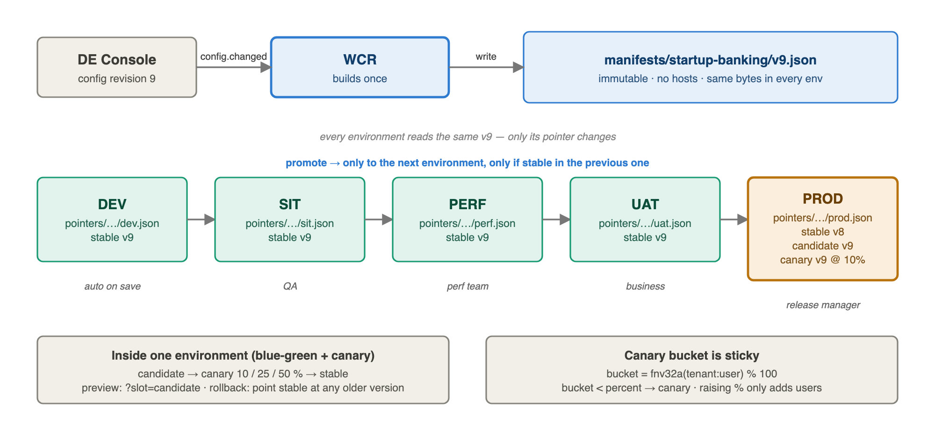
Figure 3 — Release path: one manifest built once, promoted by moving each environment's pointer
Action | API | Rule
Save config | (event) | WCR builds v(N+1); dev stable = v(N+1). Other environments untouched.
Promote to next environment | POST /manifests/{t}/promote {version, from, to} | to must be the next environment after from, and the version must be stable in from. Lands as to's candidate. Otherwise 409.
Canary | POST /manifests/{t}/{env}/canary {percent} | 0–100 % of users get the candidate. Refused if the environment has no stable version yet.
Promote candidate to stable | POST /manifests/{t}/{env}/promote | Blue-green switch inside one environment; canary reset to 0.
Rollback | POST /manifests/{t}/{env}/rollback {version, slot} | Point stable (or candidate) at any version already stable in that environment. Nothing is rebuilt.
Inspect | GET /manifests/{t}/versions · /diff?from=&to= | Every version, where it is stable, every pointer; diff of two versions.

In the target state the gates also check sign-off: promotion into uat and prod requires the gate owner's approval and attached test evidence in the release record. Who may run each action is controlled per environment (see Security).

Automated Canary Analysis and Waves
During a canary the platform compares the canary version against stable for the same tenant: server errors, latency, frontend errors and module load failures, all tagged by manifest version. If a threshold is breached, WCR rolls the canary back to 0 % automatically and alerts the release manager. Changes that touch many tenants at once, such as a bulk security update or a new runtime, are released in waves: a few low-risk tenants first, then the rest.

Concurrency and Consistency
- Single writer. Only WCR writes under manifests/, pointers/ and releases/. Release actions for one tenant are serialised.
- Conditional writes. Pointer updates use S3 conditional writes (If-Match on the ETag), so two concurrent promotes cannot overwrite each other; the loser retries or gets 409.
- Write order. Manifest first, then release record, then pointer. A pointer never references a manifest that does not exist yet.
- Audit. Bucket versioning on pointers/ keeps every previous pointer; release records keep a readable history.

Notifying the Runtime
When a pointer changes, the Web Runtime Service must reload it. The POC uses a direct webhook (POST /internal/cache-invalidate) plus a 5-second poll. In production, with many pods, a webhook to a Kubernetes Service reaches only one pod, so WCR publishes a message instead and every pod subscribes: Redis/Valkey pub/sub on ElastiCache, SNS → SQS, EventBridge, or S3 event notifications on pointers/. Losing a message is harmless because the poll catches up; the poll can then be relaxed to around 30–60 seconds.

Failure Modes
Failure | Effect | Handling
WCR down | No new builds or release actions | Users unaffected. DE Console outbox keeps events and retries.
DE Console down | No config changes | Users unaffected.
config.changed lost | Revision not built | Outbox retries with backoff; a reconcile job compares the latest revision with the latest built version.
Validation fails | Build stops | Reason shown in the DE Console; nothing released; previous version keeps serving.
S3 write fails mid-way | Partial write | Order of writes guarantees no dangling pointer; the build is retried idempotently.
Two promotes at once | Race on a pointer | Conditional write rejects one.

Security
- WCR's role is the only one with write access to the bucket prefixes; the Web Runtime Service has read-only access.
- Release API authorisation per environment: dev follows saves automatically; sit, perf and uat are promoted by their gate owners; prod by the release manager.
- In production, prod usually lives in its own account and bucket. Promotion into prod copies the immutable object across and verifies its hash through a narrow promote-only role.
- Every action is recorded with who, when and what in the release record and audit log.

Operations
- Metrics: build latency, validation failures by rule, pointer moves per environment, notification lag, versions per tenant.
- Scaling: builds are small and per tenant; one or two instances with a leader lock are enough.
- Retention: keep every manifest version; they are small. Optionally archive versions never stable anywhere after a retention period.

Web Runtime Service
The Web Runtime Service (Go) is the only part users talk to. Each environment runs its own deployment, which knows its environment name and its binding (hosts). It holds nothing durable and scales out freely.

Responsibilities
- Verify the user's token and identify the tenant.
- Pick the manifest version for this user from the tenant's pointer.
- Bind the manifest to this environment's hosts.
- Ask OCS or Resolver for personalisation and access, within a time budget.
- Render index.html with __PLATFORM_STATE__, the frame fallbacks, navigation and first-page data.

How It Knows Which Manifest to Load
1. Tenant: from the tenant domain or path, checked against the tenant claim in the token.
2. Environment: from its own deployment config; a prod pod only ever reads prod pointers.
3. Pointer: pointers/{tenant}/{env}.json, already in memory.
4. Version: chosen by the selection rule below; the manifest v{n} is already in memory.

In-Memory Caches
Cache | Key | Value | Invalidation
Pointer | (tenant, env) | Pointer + ETag | Replaced on notification or poll
Manifest | (tenant, version) | Parsed manifest | Never; versions are immutable. LRU-bounded
Bound manifest | (tenant, version, env) | Manifest with hosts applied | Never; derived from the two above

When a new pointer arrives, the service first loads any manifest it references that is not in memory, and only then swaps the pointer, so no user request ever waits on S3. Polls use conditional GETs (If-None-Match), so an unchanged pointer costs almost nothing. On start-up a pod loads the pointers and current manifests for all tenants before reporting ready.

Version Selection
bucket = fnv32a(tenant + ":" + userId) % 100 // 0..99, stable per user
if preview requested and user may preview: version = pointer.candidate ("preview")
else if bucket < pointer.canary.percent: version = pointer.canary.version ("canary")
else: version = pointer.stable ("stable")
The same user always lands in the same bucket, so canary is sticky across pods and requests, and raising the percentage only adds users. GET /debug/assign runs the same code for a list of users.

Running on Kubernetes
- Every pod holds its own copy of pointers and manifests; there is no shared cache to fail.
- Pods learn about pointer changes through pub/sub fan-out; the poll bounds any skew between pods to a few seconds.
- During that window a user is still consistent within a request, and canary assignment does not depend on which pod answers.
- Readiness requires a warm cache; liveness does not depend on S3.
- Horizontal scaling is by CPU and request rate; memory grows with tenants × versions kept, which is small.

Rendering
- index.html is rendered from a template with __PLATFORM_STATE__: tenant, environment, user, chosen version and how it was chosen, navigation, frame config and theme, and first-page data.
- Server-rendered fallbacks for header title, navigation links and footer, so the page is usable even if a frame module fails to load. Nav position and theme are applied on the server so nothing jumps.
- modulepreload hints for the runtime, frame modules and first page; a strict Content Security Policy limited to this environment's CDAaS host.
- Theme colours are re-checked as #rrggbb before they are written into CSS.

Personalisation and Access
The service calls OCS (JPMM) or Resolver (CBx) with the tenant, user, roles, environment and exact manifest version. OCS checks with OPA which pages this user and channel may see and returns visible pages, variants and boot data. The service only shows what both the manifest and the answer allow. Calls have a time budget (for example 150 ms); on timeout the page renders with the manifest defaults, and access-critical pages fail closed.

Environment Bindings
Environment | CDAaS host | Data host
dev | cdaas.dev… | api.dev…
sit | cdaas.sit… | api.sit…
perf | cdaas.perf… | api.perf…
uat | cdaas.uat… | api.uat…
prod | cdaas… | api…

Bindings are deployment config of each environment's service, not tenant config. Adding the host at request time is what lets the same manifest run unchanged everywhere.

Failure Modes
Failure | Behaviour
S3 unavailable | Keep serving the last good pointers and manifests from memory.
New pod starts while S3 is down | Not ready; existing pods keep serving.
OCS / Resolver slow or down | Manifest defaults after the time budget; access-critical pages fail closed.
Notification lost | Next poll picks up the change.
Frame or page module fails to load | Server-rendered fallback stays; other modules keep working.

Endpoints
GET /{tenant-route} render index.html (token from session)
GET /?slot=candidate preview (testers only)
GET /debug/assign?tenant=&env=&users= which version each user gets (non-prod)
POST /internal/cache-invalidate refresh a pointer now (internal only)
GET /healthz /readyz

Targets
- Server time for index.html under 20 ms at p99 excluding personalisation; no S3 or WCR call on the request path.
- Pointer change visible on all pods within 2 s with pub/sub, within the poll interval without it.

Web Runtime (Browser) and Experience Frame
The Web Runtime is a versioned browser bundle on the CDN. It boots from __PLATFORM_STATE__ without extra API calls, loads the three frame modules in parallel with the first page, and routes between pages on the client.

Module Contract
export function mount(el, ctx) { … return { setActive(id) {}, unmount() {} } }
ctx = { tenant, env, user, version, selectedBy, // who and which release
settings, theme, // frame modules: validated settings
nav: { items, activeId, navigate(id) }, // navigation helpers
data } // first-render data for pages
- Modules receive everything through ctx; behaviour per tenant comes from config and data, never from per-tenant forks.
- The nav module renders items and calls ctx.nav.navigate(id); the runtime loads that page and calls setActive(id).
- If a module fails to load or throws, the runtime keeps the server-rendered fallback and reports the error.

Frame Modules
Module | Slot | Settings
frame-header | header | title, logoUrl, showUser
frame-nav | nav | position (left | top), showIcons
frame-footer | footer | text, links [{label, url}]; the footer may be empty

Frame modules are in the same catalog as pages, marked kind: frame with a slot and a settings schema. The DE Console turns the schema into a form. A new frame design ships as a new module version without a runtime release, and is promoted, canaried and rolled back like any other change.

Runtime Bundle Rollout
The browser Web Runtime is itself a catalog entry with versions, like a module. A tenant's manifest pins runtime.version, so a new runtime is adopted, promoted, canaried and rolled back per tenant exactly like a page change. The platform team can roll a new runtime out in waves of tenants.

Data APIs After First Render
First-render data comes in __PLATFORM_STATE__. After that, modules call their backend APIs through the environment's API gateway using the user's session, never with tokens stored in JavaScript. API hosts come from the environment binding, so modules never hard-code hosts.

DE Console — Config and Module Catalog
The DE Console is the single authoring surface. Tenant owners configure tenants there, and it is the catalog where every module and version is defined. It keeps its own database of config revisions and is the source WCR builds from.

Tenant Config
- Pages: label, icon, route, default page, permission, module and exact version (empty version pins the latest at save time).
- Experience frame: module and version per slot, settings from the schema, theme colours.
- Access: roles that may open the tenant.
- Validation on save mirrors WCR's checks so owners get errors immediately.
- Each save creates revision n+1 and writes config.changed to an outbox in the same transaction; the outbox delivers it to WCR with retries.

Module Catalog
"home": {
"kind": "experience", "scope": "home", "latest": "1.1.0",
"versions": {
"1.0.0": { "path": "/home/App.js", "deployedAt": "2026-10-17T01:00:00Z" },
"1.1.0": { "path": "/home/1.1.0/App.js", "deployedAt": "2026-10-18T09:12:00Z" }
}
}
"frame-footer": { "kind": "frame", "slot": "footer", "latest": "1.0.0",
"settings": [ { "key": "text", "type": "text", "default": "" },
{ "key": "links", "type": "links", "default": [] } ], … }
- CI lists each new version after publishing it to CDAaS (target API: POST /api/modules/{id}/versions). Versions are never edited or deleted; a broken version can be marked deprecated so it cannot be newly picked.
- The console shows "↑ 1.1.0 available" next to pages and frame slots that use an older version.

Tenant Creation
A new tenant is created from a template (banking-standard, checkout-basic, starter) with pages pinned to each module's latest version and a default frame. WCR builds v1 and puts it live in dev only; other environments show "Not deployed yet" until it is promoted through the same gates.

Releases UI
The console shows every version, which environment runs which, canary shares and diffs, and calls the WCR release API for promote, canary and rollback, subject to the user's permissions per environment.

CDAaS, OCS/Resolver and OIDC Shell

CDAaS
Unchanged and already shared by both channels. Modules are published to versioned paths such as /home/1.1.0/App.js; files are never overwritten, so a fix is always a new version. Browsers load modules directly from CDAaS; the Web Runtime Service never proxies them. Each environment's runtime adds its own CDAaS host to the manifest's paths.

OCS and Resolver as Personalisation
 | Contract
Request | tenant, user, roles, environment, manifest version
Inside | OCS for JPMM, Resolver for CBx, one API. Segment rules → visible pages and variants; boot data such as account summaries from Profile and Entitlements; OCS checks access with OPA; answers cached per segment.
Response | visible pages and variants, boot data
Guardrails | Can only choose among pages and variants the manifest allows; time budget, then manifest defaults
What changes | They stop storing and promoting release config; that moves to the DE Console, WCR and S3

OIDC Shell
Signs the user in and issues the token (subject, tenant, roles, expiry). It no longer serves index.html; after sign-in it redirects to the Web Runtime Service.

End-to-End Flows

Design Time: From Tenant Creation to Production
1. A tenant owner creates the tenant from a template in the DE Console. WCR builds v1; it is live in dev.
2. A module team publishes home@1.1.0 to CDAaS; CI lists it in the DE Console catalog.
3. The tenant owner picks home@1.1.0 and clicks Save and publish. Revision 2 → config.changed → WCR builds and validates v2 → dev stable = v2 → runtime notified. Live in dev within seconds.
4. QA promotes v2 to sit (it lands as candidate, they preview it, then make it stable). The same happens for perf and uat with their owners.
5. The release manager promotes v2 to prod as candidate, canaries 10 %, 25 %, 50 %, watches metrics and promotes to stable — or rolls back by pointing stable at v1.

Runtime: Serving a Request
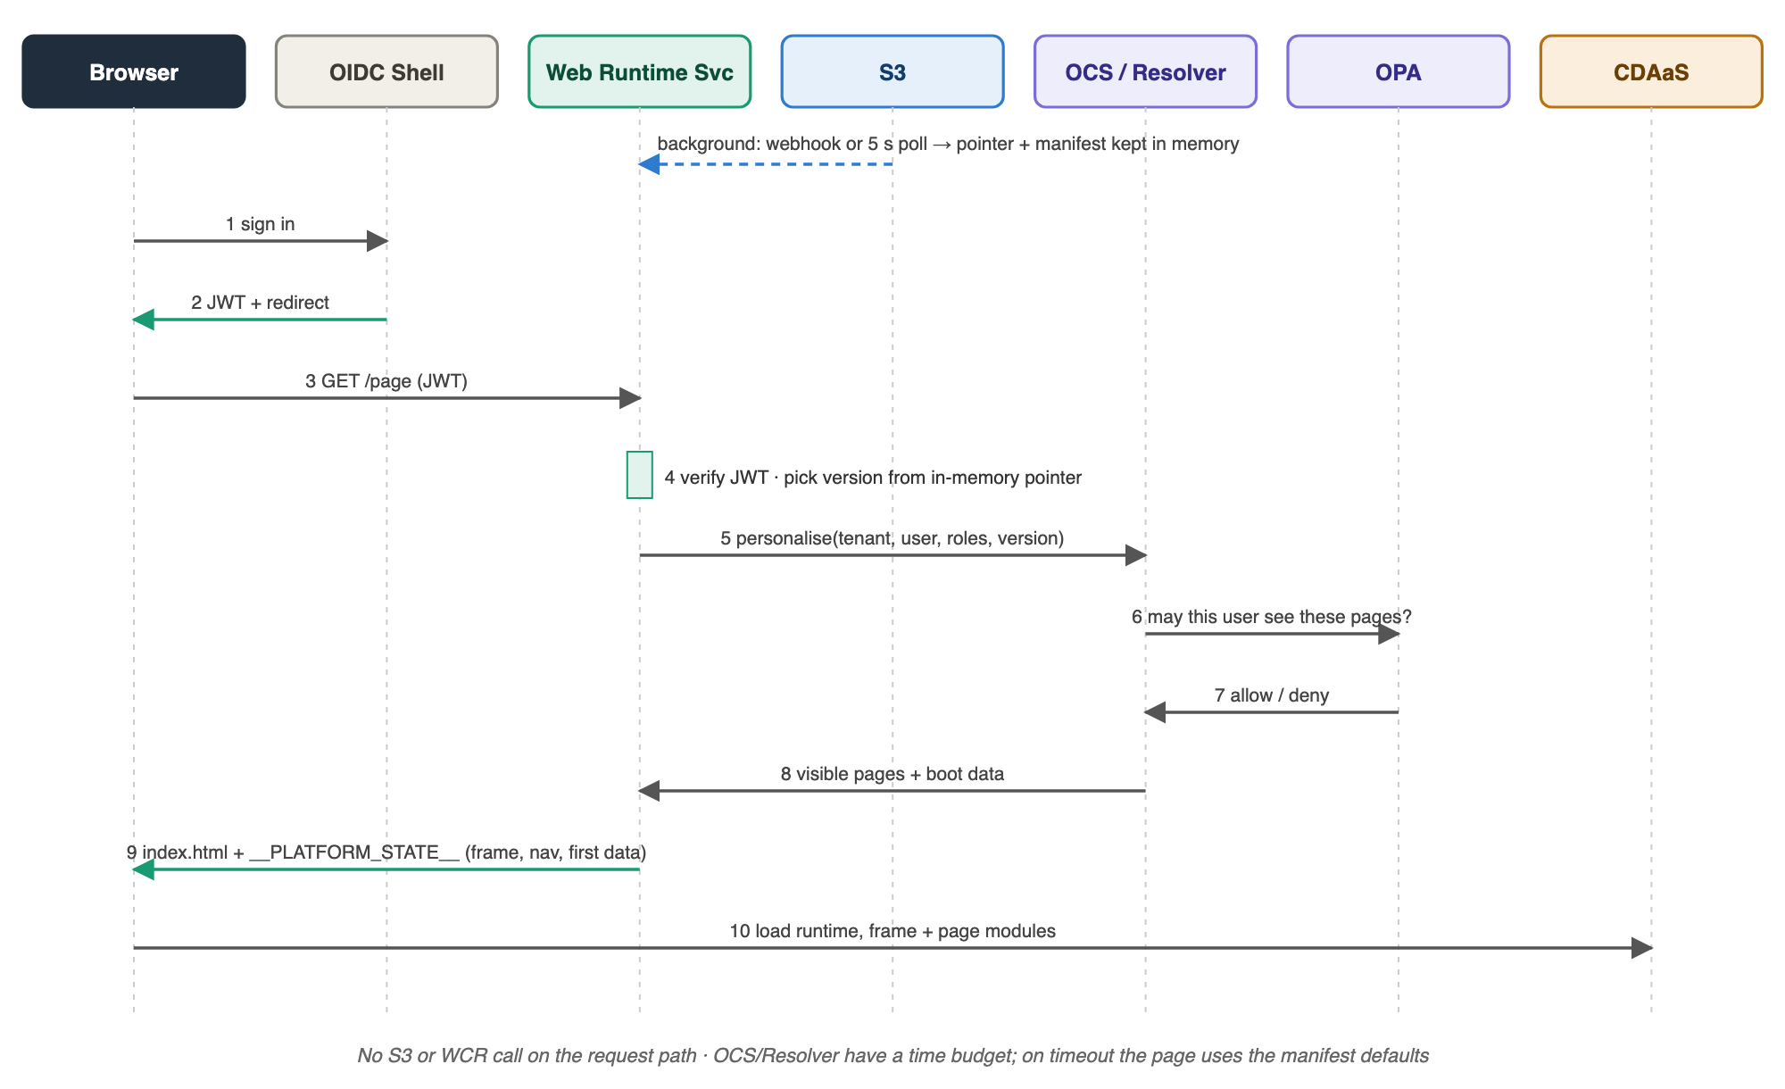
Figure 4 — Runtime: request path from sign-in to a rendered page; nothing on the path calls S3 or WCR
Step | Actor | Detail
1–2 | Browser ↔ OIDC Shell | User signs in; the shell issues a token and redirects
3 | Browser → Web Runtime Service | Page request with the token
4 | Web Runtime Service | Verifies the token; picks the version from the in-memory pointer
5–8 | Web Runtime Service → OCS/Resolver → OPA | Personalisation and access; visible pages and boot data come back within the time budget
9 | Web Runtime Service → Browser | index.html with __PLATFORM_STATE__, frame fallbacks, navigation and first data
10 | Browser → CDAaS | Loads the runtime, frame modules and first page; further pages on navigation

How a Change Reaches Users
Moment | What happens
t = 0 | Tenant owner saves; DE Console stores revision n and queues config.changed
~1 s | WCR builds and validates v{n}; writes manifest, release record and dev pointer
~1–2 s | WCR notifies; every dev pod loads v{n} into memory, then swaps the pointer
Next request | Dev users get v{n}; other environments are unchanged until promoted

Developer Workflow
Two roles, one hand-off. Developers build and publish module versions; tenant owners decide which versions their tenant uses. Developers never edit tenant config or touch S3, and the same gates apply to every change.
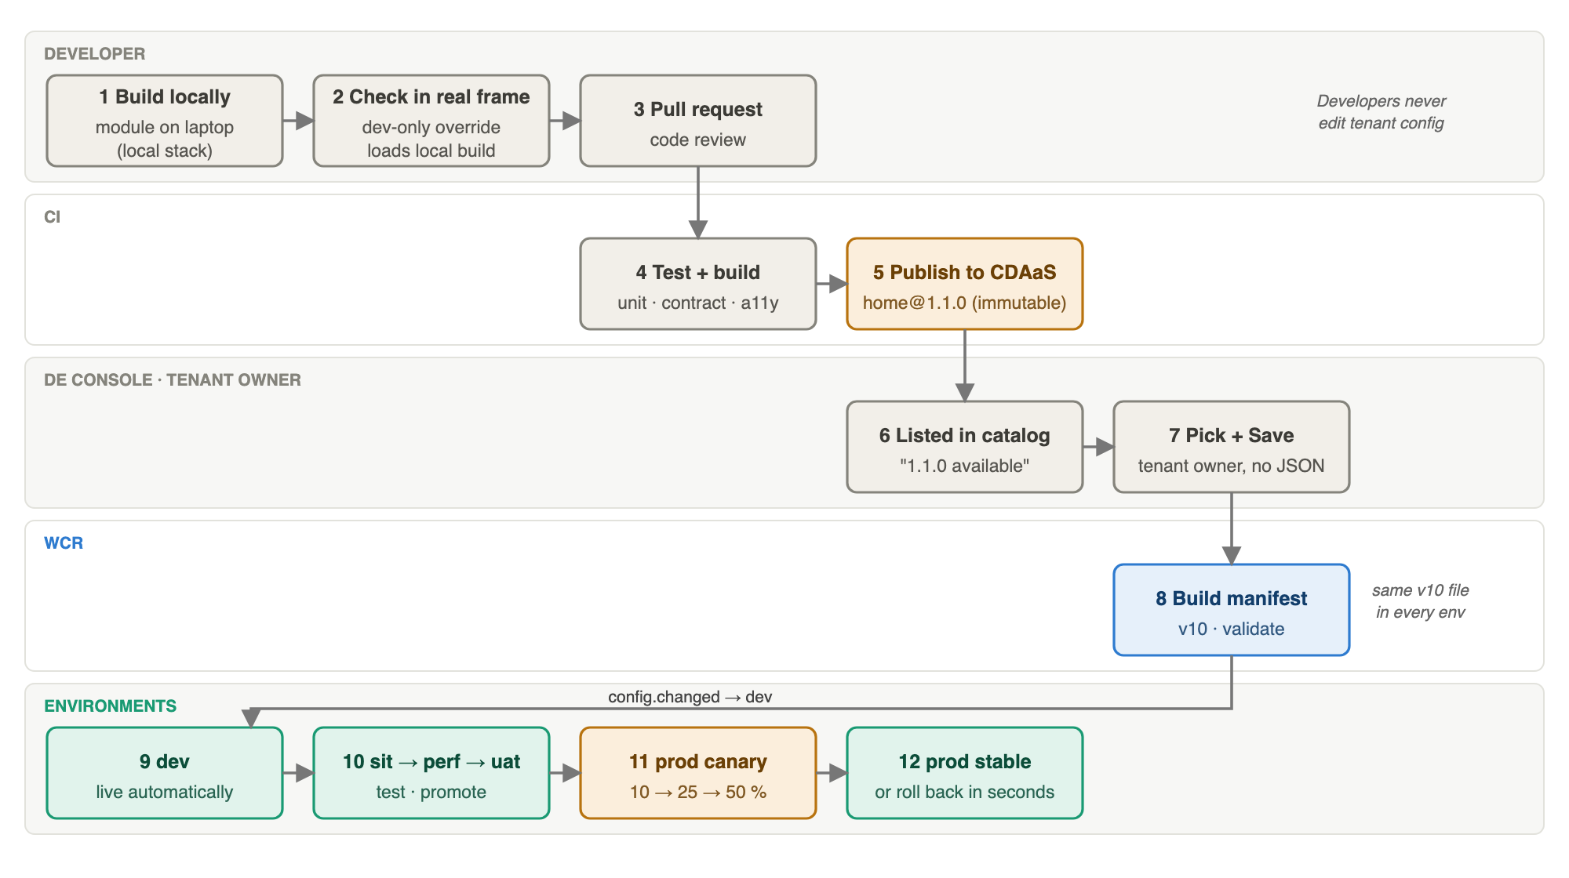
Figure 5 — Developer workflow: from a laptop to production

Roles
Who | Owns | Typical action
Module team (developers) | Page and frame modules | Build, test, publish home@1.1.0
Tenant owner | Tenant config and frame in the DE Console | Pick versions, Save and publish
QA, performance, business | sit, perf and uat gates | Preview the candidate, test, promote
Release manager | prod | Canary, promote, roll back
Platform team | Runtime, WCR, catalog rules, OPA policy | Runtime and policy changes

1. Develop Locally
- Run the module's dev server (for example on localhost:5173). The module exports mount(el, ctx) and gets everything from ctx.
- Optional full local stack with docker compose: DE Console stand-in, WCR, S3-compatible storage, Web Runtime Service, OIDC Shell and a CDAaS stand-in, seeded with sample tenants.
- Unit tests and contract tests run against a mocked ctx, including frame and navigation helpers.

2. Check It Inside the Real Frame
A dev-only override makes the runtime load a local build in place of one module for the current browser session, for example ?override=home=http://localhost:5173/App.js. It is honoured only by the dev environment's runtime, only for allow-listed origins, and never changes tenant config or any manifest. This lets developers see their module inside the tenant's real frame, navigation and data.

3. Pull Request and CI
1. Open a pull request; peers review it.
2. CI runs lint, unit tests, contract tests against the runtime ctx, accessibility checks and a bundle-size budget.
3. On merge, CI builds the release and publishes it to CDAaS at /home/1.1.0/App.js. Paths are immutable; a fix is 1.1.1.
4. CI lists home@1.1.0 in the DE Console catalog with its path, deploy time and (target) compatibility metadata.

4. Adopt the Version
The tenant owner sees "↑ 1.1.0 available" in the DE Console, picks it for the page and clicks Save and publish. WCR builds a new manifest, and it is live in dev within seconds. Different tenants adopt at their own pace, and dev can run home@1.1.0 while prod still runs 1.0.0.

5. Promote Through the Environments
Environment | Who | What is checked
dev | Automatic on save | Developer and owner smoke test
sit | QA | Integration and regression tests on the candidate (preview), then stable
perf | Performance team | Load and latency budgets
uat | Business | Acceptance and sign-off
prod | Release manager | Canary 10 → 25 → 50 %, error and latency metrics, then stable

6. Roll Back or Fix
- Rollback: point prod's stable at the previous version. It takes seconds, rebuilds nothing and leaves other environments untouched.
- Fix forward: publish home@1.1.1, the tenant owner picks it, and it goes through the gates; gates can be passed quickly but are never skipped.

Frame Changes
Changing the footer text, switching navigation to the top or changing theme colours is a config change in the DE Console and follows the same path: new manifest in dev, then promotion. A new frame design is a new frame module version published like any module.

What Developers Never Do
- Edit tenant config or any manifest by hand.
- Write to S3 or call WCR release actions for environments they do not own.
- Overwrite a published module version.
- Fork a module per tenant; tenant differences come from config and data.

Example: A Day in the Life
Time | Who | Step
09:00 | Developer | Builds a Runway card for Home locally; checks it in the real frame with the dev override
11:30 | CI | Tests pass; publishes home@1.1.0 to CDAaS; lists it in the DE Console
11:45 | Tenant owner | Picks home@1.1.0 for startup-banking; Save and publish → v10 live in dev
14:00 | QA | Promotes v10 to sit, previews, makes it stable
Day 2 | Perf, business | Promote through perf and uat
Day 3 | Release manager | prod: canary 10 % → 50 % → stable; rollback to v9 available throughout

Observability
Safe releases depend on seeing the effect of each version. Every signal is tagged with tenant, environment, region, manifest version and how the version was chosen (stable, canary or preview).
Signal | Source | Used for
Request logs and traces | Ingress, Web Runtime Service, OCS/Resolver | Latency per hop; one trace id from ingress through personalisation
Server metrics | Web Runtime Service | Render time, personalisation timeouts, cache warmth, pointer age
Real-user monitoring | Browser Web Runtime | Page load, module load failures, JavaScript errors per module version
Release events | WCR | Builds, validation failures, pointer moves, notification lag per region
Synthetic checks | Per tenant per environment | Sign-in and first page every minute, including after each promote

- Per-version dashboard: stable versus canary side by side for every tenant; this is what automated canary analysis reads.
- Alerts: canary regression, pointer older than expected in any region, personalisation timeout rate, module load failures above baseline.

Resiliency

Principles
- Control plane off the request path. The DE Console, WCR and S3 can all be down without users noticing; only releases pause.
- Static stability. Pods keep everything they need in memory and keep serving the last good state when a dependency fails.
- Immutable data. Manifests never change, so caches never go stale or wrong.
- Fail soft for personalisation, fail closed for access. Personalisation falls back to manifest defaults; pages that need an access decision are not shown without one.
- Bounded blast radius. Every change is per tenant, gated, canaried and reversible; wide changes go in waves.

Request-Path Dependencies
Dependency | Risk | Mitigation
OCS + OPA (access) | On the hot path for every page; fail closed means an OCS outage blocks users | Circuit breaker; cache access decisions per role and segment for a short TTL; last-known-good policy bundle so access can be evaluated locally in an emergency; precise list of which pages fail closed
OCS / Resolver (personalisation) | Slow answers delay first paint | Time budget, stale-while-revalidate per segment, load shedding
Identity provider / OIDC Shell | No sign-in, no access | Multi-AZ and multi-region; JWKS cached in the Web Runtime Service; existing sessions keep working until expiry
CDAaS / CDN | Modules fail to load | CDN origin failover across two regions; server-rendered frame fallbacks
S3 | No new releases; new pods cannot load state | Running pods serve from memory; pods persist a last-good snapshot so new pods can start without S3
Web Runtime Service | A bad deployment of the service itself | Pods across three AZs, pod disruption budget, canary rollout of the service, autoscaling with headroom

Cold Start Without S3
Each pod writes the pointers and manifests it holds to a local snapshot (or a small shared snapshot refreshed every few minutes). A new pod starts from the snapshot, becomes ready, then catches up from S3 when it is reachable. This lets the service scale out during an S3 outage.

Tenant Isolation
Per-tenant rate limits at ingress and per-tenant concurrency limits towards OCS/Resolver stop one tenant's traffic spike from affecting others. If needed later, tenants can be grouped into cells, each with its own Web Runtime Service deployment, so a fault in one cell cannot reach the others.

Service Level Objectives (proposed)
Objective | Target
Page availability (index.html served) | 99.95 % per month
Server render time, excluding personalisation | p99 < 20 ms
Pointer change visible on all pods in all regions | p99 < 5 s
Rollback effective everywhere | < 30 s
Release availability (DE Console + WCR) | 99.9 %

Proving It
Chaos drills run before each phase exit and then quarterly: block S3, stop OCS, kill an availability zone, evacuate a region, deliver a broken module version, and drop notifications. Each drill has an expected outcome taken from the tables above.

Multi-Region
The design suits multi-region because the request path needs only read-only, immutable files plus one small pointer per tenant. Serving runs active-active in every region; the control plane runs active in one region with a standby.
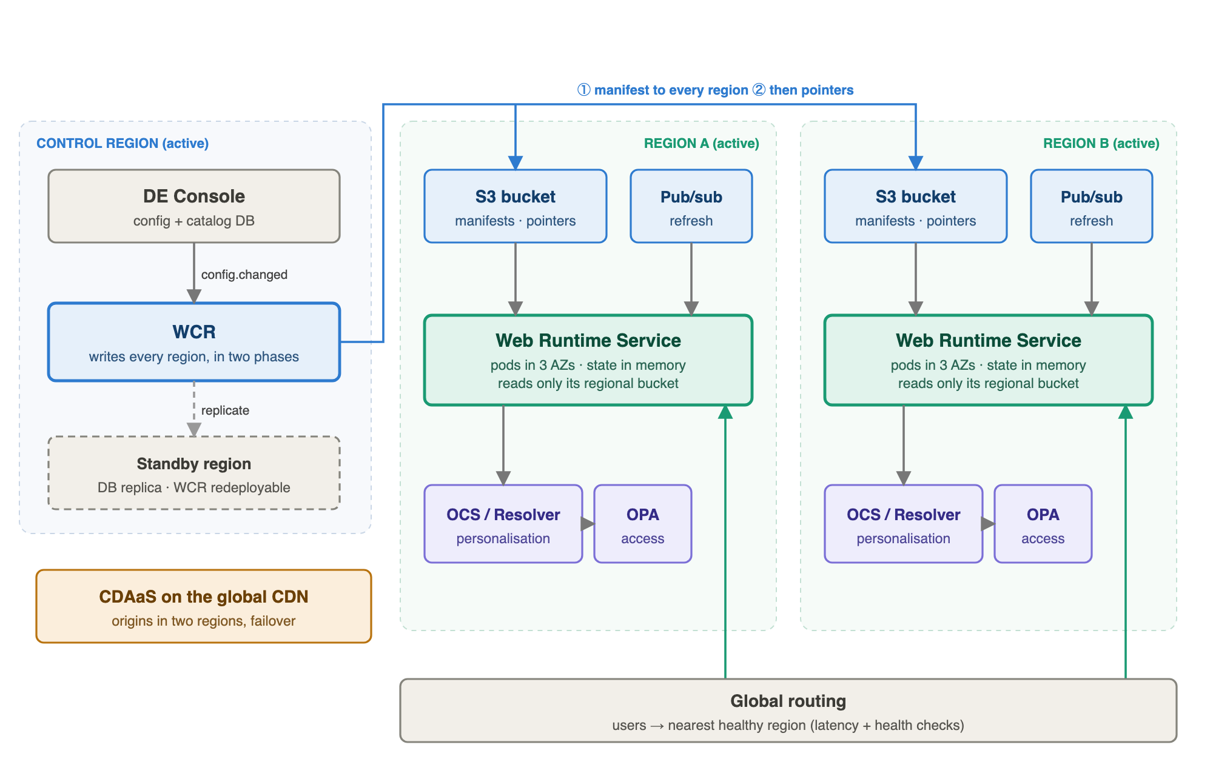
Figure 6 — Multi-region: one control region writes every region's bucket in two phases; each region serves on its own

Control Plane: One Active Region, One Standby
The DE Console and WCR run in one region. The DE Console database replicates to a standby region, and WCR, which keeps no state of its own, can be redeployed there. Losing the control region only pauses releases, so a recovery time of under an hour is acceptable.

Storage: Regional Buckets, Written in Two Phases
Every serving region reads its own bucket, so there are no cross-region reads at request time. WCR writes to every region explicitly rather than relying on S3 Cross-Region Replication, which does not guarantee ordering:
1. Write the manifest and release record to every region and wait for each to confirm.
2. Then write the pointer to every region and publish the refresh message in each.
A pointer therefore never arrives before its manifest. Regions converge within seconds; the release record shows the state per region. If a region is unreachable, WCR retries and that region keeps serving its previous version safely; an alert fires if a region falls behind. Cross-Region Replication can still be used as a backup copy.

Serving: Active-Active
- The Web Runtime Service runs in every region with pods across three availability zones, reading its regional bucket and regional pub/sub.
- Global routing sends users to the nearest healthy region using latency-based routing and health checks.
- Sessions are stateless tokens, so a user moved to another region during failover carries on without signing in again.
- Canary is consistent across regions: the bucket is a hash of tenant and user, and pointers are identical once converged.
- Each region is sized to take the other's traffic (N+1) so a region evacuation does not overload the survivor.

Dependencies Must Be Multi-Region Too
OCS, Resolver, OPA, Profile, Entitlements and the identity provider need regional deployments, or at least a defined fallback (cached decisions, manifest defaults). In practice the platform is only as available as these dependencies, so their multi-region posture is a prerequisite for the targets below. CDAaS is already global through the CDN; it needs an origin in a second region.

Optional: Regions as Release Waves
Prod can later be released region by region, with a pointer per region (pointers/{tenant}/prod/{region}.json): canary in one region first, then the others. This limits blast radius at the cost of some complexity. The proposal is to start with one logical prod pointer written to every region and add region waves only if needed.

Data Residency
If some tenants must stay in specific regions, the tenant's config lists its allowed regions. WCR writes that tenant's manifests and pointers only to those regions, and routing pins the tenant's domain to them.

Recovery Targets (proposed)
Component | Pattern | RTO | RPO
Web Runtime Service | Active-active | ~0 (routing failover) | 0 (immutable data)
S3 manifests and pointers | A copy per region | 0 | Seconds (latest release may lag)
WCR | Active-passive | < 1 h | 0 (state is in S3)
DE Console | Active-passive with DB replication | < 1 h | Minutes
OCS / Resolver / OPA / identity | Owned by those teams | Their targets | Their targets

Region Failover Runbook (outline)
1. Health checks fail for a region; global routing stops sending users there automatically.
2. The surviving region scales out; it already holds every tenant's current version.
3. WCR keeps writing to the healthy region and marks the failed region as behind.
4. When the region returns, WCR replays the latest manifests and pointers to it before routing sends users back.

Security
The design follows four principles: least privilege for every identity, immutable artefacts that are verified before use, no trust between services without authentication, and defence in depth in the browser.

Threats and Controls
Threat | Controls
Tampered or replaced module file on CDAaS or the CDN | Integrity hash (SRI) for every module in the manifest; immutable versioned paths; only CI's identity can write to CDAaS; object lock on published versions
Malicious or vulnerable dependency in a module (supply chain) | CI dependency and static analysis scans; signed builds with provenance; an SBOM stored with each catalog version; WCR refuses versions marked blocked
Tampered manifest or pointer | Only WCR's role can write; bucket versioning and object lock on manifests; manifest hash in the release record; optionally WCR signs manifests with a KMS key and the runtime verifies the signature
Unauthorised release (promote, canary, rollback) | Single sign-on for the DE Console; per-environment role-based permissions; two-person approval for prod; every action audited
Cross-site scripting through config values | DE Console and WCR validation: http(s) URLs only, #rrggbb colours, length limits; the runtime and frame modules escape every value; strict Content Security Policy
Injected or third-party script | CSP allows scripts only from this environment's CDAaS host plus a per-request nonce for the inline state; Trusted Types; no inline event handlers
Token theft or session hijack | Session in HttpOnly, Secure, SameSite cookies; short-lived tokens refreshed through OIDC; no tokens in __PLATFORM_STATE__ or JavaScript; JWKS rotation
Cross-tenant data leakage | Tenant from the host must match the token's tenant claim; caches keyed by tenant; OPA checks tenant membership; automated cross-tenant tests
Dev-only override used in other environments | Honoured only when the environment binding enables it (dev only) and only for allow-listed origins
Sensitive data exposed in the page | __PLATFORM_STATE__ contains only what this user may see; no secrets; personal data minimised; HTML sent with Cache-Control: no-store
Denial of service and scraping | WAF and bot protection at ingress; rate limits per tenant and per client; load shedding in the Web Runtime Service
Clickjacking | frame-ancestors 'none' (or an allow-list for approved embedding)
Internal endpoints exposed | /internal/* and /debug/* are not routed through ingress; debug endpoints disabled in prod

Identities and Permissions
Identity | Can | Cannot
Developer | Push code, open pull requests, use the dev-only override in dev | Publish to CDAaS directly, change tenant config, run release actions
CI pipeline | Publish new module versions to CDAaS; list them in the catalog | Overwrite a version, change tenant config, write to S3
Tenant owner | Change their tenant's config in the DE Console | Change other tenants, promote beyond dev
Gate owner (QA, perf, business) | Promote, preview and canary in their environment | Act in other environments
Release manager | Canary, promote and roll back in prod (with approval) | Change config or modules
WCR service role | Read config snapshots; write manifests, pointers and release records | Read user data or serve traffic
Web Runtime Service role | Read pointers and manifests; call OCS/Resolver | Write to S3, call the WCR release API

Service-to-Service Security
- Mutual TLS between services (service mesh), with workload identities instead of shared secrets.
- config.changed events are authenticated (signed or delivered over an authenticated channel); WCR rejects unsigned events.
- Refresh notifications to the Web Runtime Service are authenticated; a forged notification can only trigger a re-read of S3, never inject data.
- Cloud permissions per role as in the table above; the Web Runtime Service has read-only access to its regional bucket.

Browser Hardening
Content-Security-Policy:
default-src 'none';
script-src 'nonce-{per-request}' https://{env CDAaS host};
style-src 'self' 'nonce-{per-request}' https://{env CDAaS host};
img-src 'self' https: data:;
connect-src 'self' https://{env API host};
frame-ancestors 'none'; base-uri 'none'; require-trusted-types-for 'script'
Strict-Transport-Security: max-age=31536000; includeSubDomains
X-Content-Type-Options: nosniff
Referrer-Policy: strict-origin-when-cross-origin
Cache-Control: no-store (index.html only)

Module Integrity in the Manifest
"experience": {
"path": "/home/1.1.0/App.js", "moduleVersion": "1.1.0",
"integrity": "sha384-oqVuAfXRKap7fdgcCY5uykM6+R9GqQ8K/uxy9rx7HNQlGYl1kPzQho1wx4JwY8wC"
}
CI computes the hash when it publishes a version and lists it in the catalog; WCR copies it into the manifest; the runtime passes it to the browser when loading the module. A file that does not match is refused and the fallback stays on screen.

Data Protection
- Encryption in transit (TLS 1.2+) everywhere and at rest (KMS-managed keys) for S3 and the DE Console database.
- Manifests and config contain no secrets and no personal data; WCR rejects values that look like credentials.
- Logs redact tokens and personal data; retention follows the bank's policy.

Assurance
- Threat model reviewed at each phase exit; penetration test before Phase 3 (first real tenants on manifests).
- Release records and audit logs are append-only and retained for audit.
- Quarterly access reviews of DE Console roles and release permissions.

Key Design Decisions
Decision | Rationale
Manifests generated, not authored | Owners edit config in one place; the manifest is a build output and is always complete and valid (replaces v5 "manifest.json, config-as-code").
DE Console is the module catalog | One place where modules and versions are defined; no separate Registry to run and keep in sync.
No silent auto-patch | Every change users see is a new manifest version that passes the gates; owners adopt versions explicitly.
S3 for manifests and pointers | Durable, versioned, cheap and simple; no database to run; immutable objects suit build-once.
Paths, not hosts, in manifests | The same file is promoted from dev to prod; hosts are bound per environment.
A pointer per tenant per environment | A release is a tiny pointer change; rollback takes seconds.
WCR off the request path | A control-plane outage pauses releases but never affects users.
Serve from memory | No network hop to load config; static stability when dependencies fail.
OCS and Resolver retained for personalisation | Reuse working personalisation; they stop storing release config.
OCS calls OPA | Access decisions stay with the service that knows entitlements; one policy enforcement point.
ElastiCache only as a notification channel | In-memory stores are not a durable source of truth for releases; pub/sub suits fan-out to pods.
Go for the Web Runtime Service | Fast HTML render, small binary, no JVM warm-up.
OIDC Shell decoupled from HTML serving | Auth and delivery scale and fail independently.
CDAaS unchanged | Module delivery is already solved and shared.
Regional buckets written in two phases | Every region reads locally, and a pointer never arrives before its manifest.
Integrity hashes for every module | "Immutable" files are verified, not just trusted.

Phased Transition Plan
Weeks are indicative. No big bang: each phase can run alongside the current stacks.
Phase | Weeks | Name | Key deliverables | Exit milestone
1 | 1–4 | OIDC decoupling | Web Runtime Service introduced as a thin wrapper; OIDC Shell stops serving index.html | OIDC Shell no longer serves HTML
2 | 5–10 | WCR and shadow mode | WCR, S3 layout, DE Console catalog and outbox; DE Console changes also go to WCR; manifests compared with what OCS serves | Manifests match OCS for JPMM tenants
3 | 11–16 | JPMM on manifests | JPMM tenants served from manifests one at a time with OCS as fallback; personalisation contract live; environments and gates in use | All JPMM tenants on manifests
4 | 17–22 | CBx on the same path | CBx modules defined in the DE Console catalog; Resolver as personalisation; CBx Registry retired | CBx tenants on manifests
5 | 23–28 | One browser runtime | Single Web Runtime and frame modules replace CBx and JPMM runtimes | One runtime for both channels
6 | 29–32 | Consolidation | OCS and Resolver stop storing config; JPMM runtime metadata DB retired; legacy paths removed | One platform

Risks and Mitigations
Risk | Likelihood | Impact | Mitigation
Generated manifests differ from what OCS serves today | Medium | High | Shadow mode in Phase 2 compares every manifest before cutover
Concurrent release actions corrupt a pointer | Low | High | Single writer, S3 conditional writes, versioned pointers
Pods briefly serve different versions | Medium | Low | Pub/sub fan-out, poll bound, sticky canary by user
S3 unavailable | Low | Medium | Serve from memory; readiness needs a warm cache; replicated prod bucket
OCS/Resolver latency hurts first paint | Medium | Medium | Time budget, manifest defaults, per-segment caching
Module incompatible with the runtime version | Medium | Medium | Compatibility metadata in the catalog, WCR checks, canary
Dev override misused outside dev | Low | High | Honoured only by the dev runtime and allow-listed origins
Tenants slow to adopt new versions | Medium | Low | "Available" hints; optional auto-adopt policy for patches (open question)
OPA policy migration breaks access | Medium | High | Policy tests in parallel during shadow mode
A region falls behind on releases | Medium | Medium | Two-phase writes, per-region status in the release record, alert on lag
Compromised module dependency | Low | High | Scans, signed builds, SBOM, integrity hashes, block-listing in the catalog
OCS outage blocks access (fail closed) | Low | High | Circuit breaker, cached decisions, last-known-good policy bundle

Open Questions
- Roles per page: do page-level role requirements stay in tenant config, or move entirely into OPA policy?
- Personalisation authoring: are segments and variants authored in the DE Console or inside OCS/Resolver?
- Resolver and OPA: does Resolver also call OPA for CBx, or only OCS?
- Auto-adopt: should tenants be able to opt in to automatic adoption of patch versions (still built as a new manifest and gated)?
- Prod isolation: separate account and bucket for prod with copy-on-promote, or one bucket with stricter IAM?
- Notification channel: Redis/Valkey pub/sub, SNS → SQS, EventBridge or S3 event notifications?
- Embedded OPA: if access checks add too much latency, should the Web Runtime Service evaluate a policy bundle locally?
- Region waves: one logical prod pointer for all regions, or a pointer per region released in waves?
- Manifest signing: are integrity hashes plus write-restricted buckets enough, or should WCR also sign manifests?
- SLOs and recovery targets: confirm the proposed numbers with operations and the OCS team.

Appendix A — API Reference

DE Console
GET /api/tenants GET /api/modules GET /api/templates
POST /api/tenants {tenantId, displayName, template, role} -> revision 1, live in dev
GET /api/configs/{tenant} latest config + revision
PUT /api/configs/{tenant} validate, new revision, emit config.changed
GET /api/configs/{tenant}/revisions/{n} snapshot WCR builds from
POST /api/modules/{id}/versions (target) CI lists a new version

WCR
POST /events config.changed -> 202, build async, release to dev
GET /manifests/{tenant}/versions all versions (+ stableIn) and every pointer
GET /manifests/{tenant}/versions/{n} one immutable version
GET /manifests/{tenant}/diff?from=&to=
POST /manifests/{tenant}/promote {version, from, to} -> next env's candidate (gated)
POST /manifests/{tenant}/{env}/canary {percent: 0-100}
POST /manifests/{tenant}/{env}/promote candidate -> stable
POST /manifests/{tenant}/{env}/rollback {version, slot: stable|candidate}
GET /manifests/{tenant}/{env}/{slot} the manifest a slot points at

Web Runtime Service
GET /… render index.html
GET /debug/assign?tenant=&env=&users= version per user (non-prod)
POST /internal/cache-invalidate refresh a pointer now

Appendix B — Proof-of-Concept
A runnable proof-of-concept validates this design end to end (docker compose up): DE Console stand-in with catalog, templates and frame editor; WCR; S3-compatible storage; Web Runtime Service; OIDC Shell; CDAaS stand-in; and a demo script that creates a tenant, publishes a change, promotes it through all five environments, canaries and rolls back.
Component | POC service | Simplified in the POC
DE Console | control-plane | Catalog is a seed file; no CI listing API
WCR | wrcs | Pointer writes serialised by a mutex instead of S3 conditional writes; no approvals
S3 | SeaweedFS | One bucket for all environments
Web Runtime Service | web-runtime-service | One service for all environments, picked by ?env=; OPA evaluated in-process
OCS / Resolver | — | Not modelled beyond server-fetched first-page data
OIDC Shell | oidc-shell | Demo tokens with a shared secret
CDAaS | cdaas-mock | Plain ES modules instead of Module Federation

